Unity project deployment to Oculus Quest 2

Created by Linfeng Wu, updated on 08/19/2023

Instructions for Unity project deployment to Oculus Quest 2.

Note: The previous SOP about Unity and Oculus Integration plugin showed how to create a Unity project using Oculus Integration. This SOP is a follow up to illustrate how to deploy a Unity project to the device (Oculus Quest 2). The steps will start from the Unity project created in the Unity and Oculus Integration plugin SOP.

Downloads:

Meta Quest app for phone or tablet: <https://www.meta.com/help/quest/articles/getting-started/getting-started-with-quest-2/install-meta-quest-mobile-app/>

SideQuest (Advanced Installer): <https://sidequestvr.com/setup-howto>

Required Items: Oculus Quest 2; Link Cable.

Steps:

1. Set up the Unity project as described in the Unity and Oculus Integration plugin SOP.

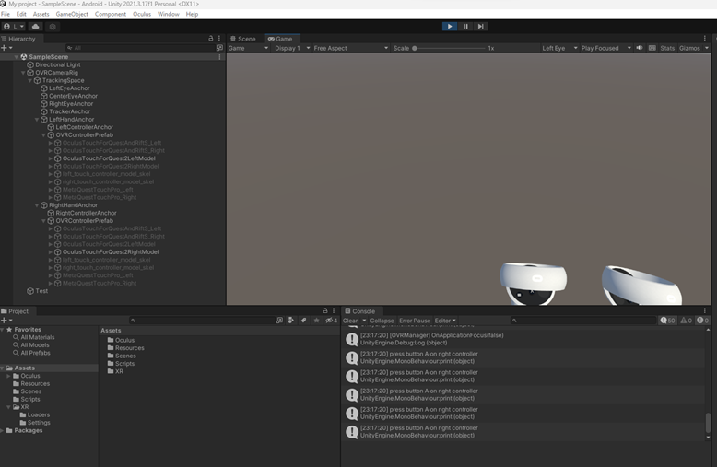

1. Build the APK file from the Unity project.

* Open the project in Unity editor, go to File->Build Settings, change the platform to Android, set the Texture Compression type to ASTC and then click “Switch Platform”.

* After the platform is switched, you can click “Build”. You'll be asked to select a folder where the APK should be stored. It is recommended to create a folder named “Build” under the project folder.
* After the build is done (which might take a few minutes), you now have the APK file in the selected folder to be deployed to the device.

1. Enable Oculus Quest 2 developer mode.

* Create a Meta account (not necessary if you already have one): <https://auth.meta.com/>
* Register as a developer on the Oculus website: <https://developer.oculus.com/manage/organizations/create/>. From the developer dashboard you must verify your account by adding a credit card (required) and setting up two-factor authentication.

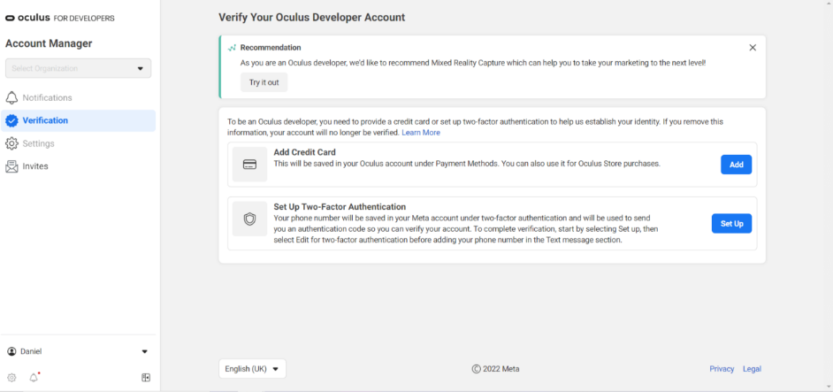

* Once verified, if you don’t have an organization that you already need to join, you should now “Create a New Organization” <https://developer.oculus.com/manage/organizations/create/>
* Agree to the agreement and click submit. You now have a developer account.

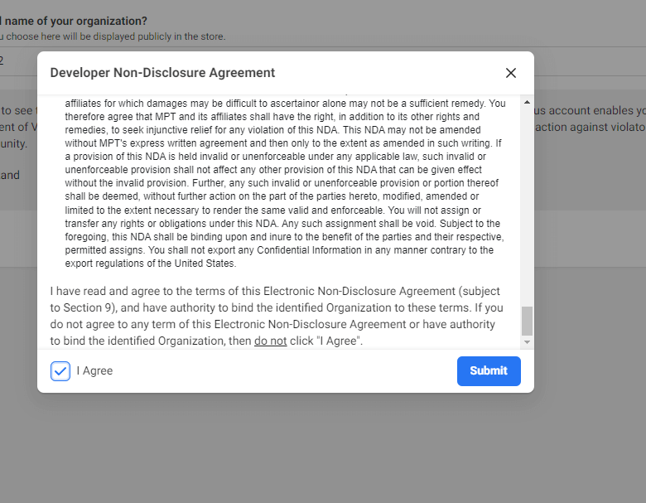

1. Turn on developer mode on Oculus Quest 2.

* Turn on the headset and sign in with the same account you just verified.
* On your phone or tablet, go to the Quest application and sign in with the same account.
* Go to “Menu” then click the “Devices” icon.
* Make sure the headset is connected to the same Wi-Fi as your mobile device. Your headset should show under “Devices” and with status “Connected”.

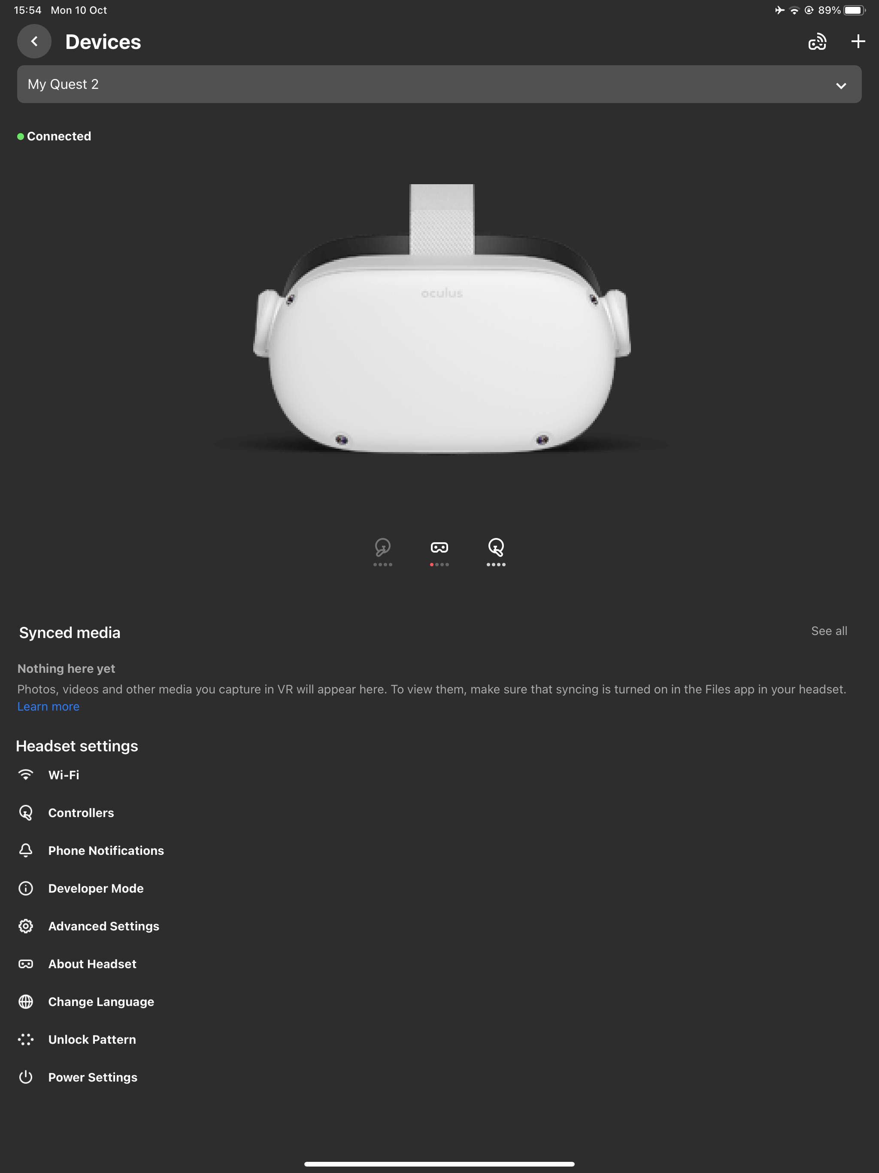

* Then go to Headset settings -> Developer Mode, toggle the developer mode option to on.

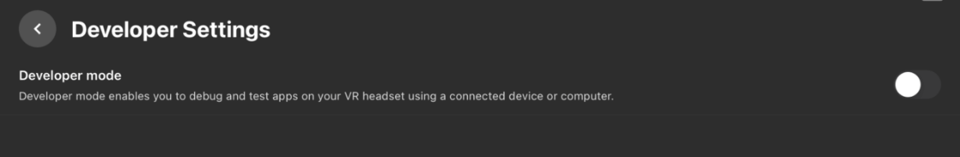

1. Connect Oculus Quest 2 to SideQuest.

* Download the Advanced SideQuest Installer: <https://sidequestvr.com/setup-howto> and launch SideQuest.

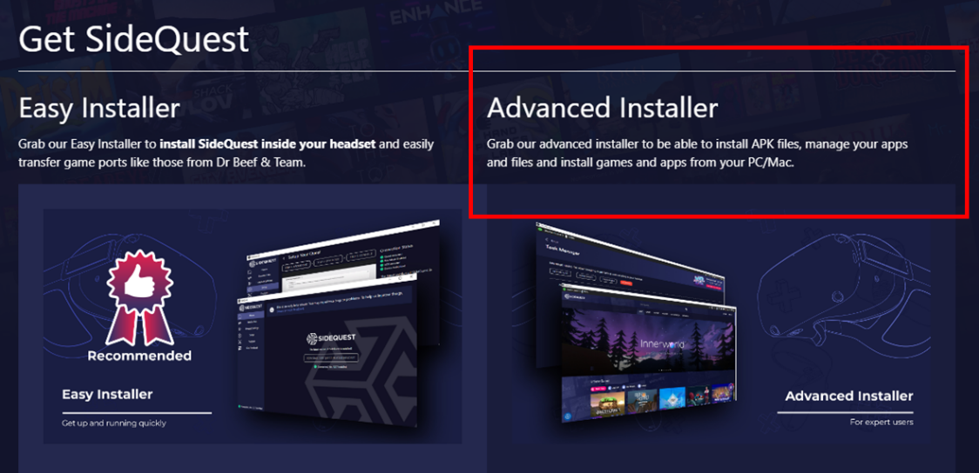

* Using the USB cable that came with your headset, connect it to your computer.
* When you put the headset on, select “Allow USB debugging”, “Always allow from this computer” and Allow on the respective prompts.
* Quest 2 should now be connected (connection status is indicated in the top-left corner of the SideQuest application).

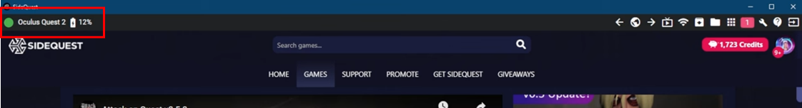

1. Install APK file to Oculus Quest 2.

* Select “Install APK file from folder on computer” on the SideQuest application.

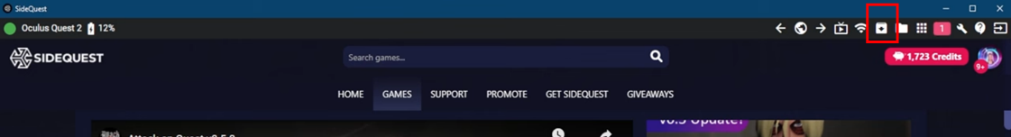

* Navigate to the APK file you built from the Unity project via your Windows file directory and double click the file. The deployment might take a few minutes.
* After the deployment is complete (now you may disconnect it from your computer), put on your headset.
* Navigate to the home screen on your Quest 2 and open the App Library and select the dropdown menu in the top-right and change the filter to Unknown Sources.

* Select the installed APK application and click it to launch it.

